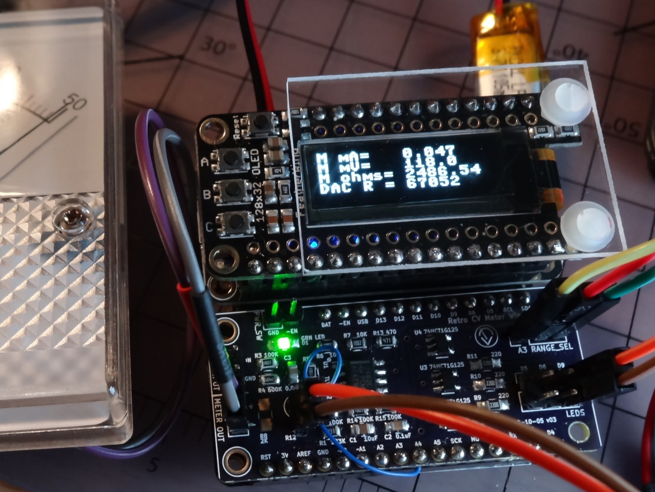

Retro CV Meter Interfaces

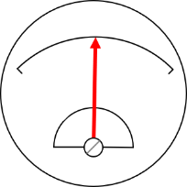

Jan Goolsbey, Cedar Grove Studios

# The Retro CV Meter Interfaces

## Overview

## Trinket M0 Version

## Feather M0/M4 Wing Version

